To add to text:

Drifters mean speeds (standard deviation) for TIDE, WIND, WAVE were 8.7 (6.0), 6.9 (5.4), 12.9 (7.2) cm s-1, respectively (Table 1). Probability plots and histograms showed that the distributions of drifter speeds were normal only during WAVE; distributions were non-normal during TIDE and WIND (Figure 1 b). The results of both parametric pair-wise Student’s t-test and non-parametric pair-wise Mann-Whitney u-test supported the conclusion that drifter speeds were significantly different during TIDE, WIND, and WAVE.

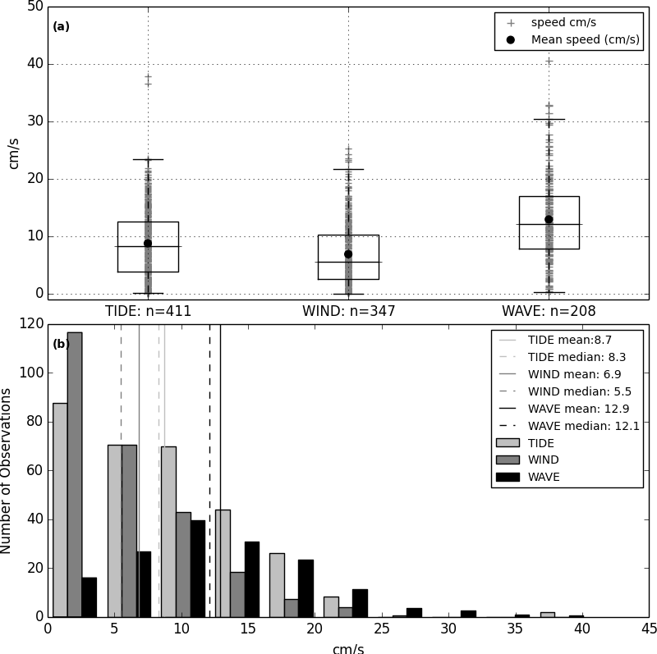

Figure 1. (a) Boxplots and (b) histograms of all drifter speeds (cm s-1) during end member periods TIDE, WIND, and WAVE. Both parametric pair-wise t-tests and non-parametric pair-wise Mann-Whitney u-tests supported the conclusion that mean speeds for each end member period are significantly different than each other (p<0.001).

|  |  |  |  |
| --- | --- | --- | --- |
| **Table 1.** Time frames defining the end-member meteorologic and oceanographic forcing periods. | | | |
|  | Wind | Tide/Calm | Wave |
| Year Day 2014 | 47-49 | 50-51 | 52-55 |
| Gregorian Day (UTC) | 2/16-2/18 | 2/19-2/20 | 2/21-2/24 |
| Gregorian Day (Local) | 2/15-2/17 | 2/18-2/19 | 2/20-2/23 |
| ADCP mean speeds at AS1, AS2, AS3 (cm s-1) | 11.6, 3.9, 1.5 | 14.6, 5.3, 0.9 | 18.1, 10.9, 1.2 |
| ADCP mean speed for end member (cm s-1) | 5.7 | 6.9 | 10.1 |
| ADCP standard deviation (cm s-1) | 4.3 | 5.7 | 6.9 |
| Drifters speed min - max (cm s-1) | 1-37 | 1-37 | 5-64 |
| Drifter mean speed for end member (cm s-1) | 6.9 | 8.7 | 12.9 |
| Drifter standard deviation (cm s-1) | 5.4 | 6.0 | 7.2 |
| Drifters number of samples (n) | 347 | 411 | 208 |

## Full results of statistical significance tests

p=0.001

### Parametric statistical tests

TIDE, WIND, and WAVE are significantly different than each other. ANOVA: f = 65.037 p = 3.2071e-27

TIDE and WIND are significantly different than each other. t = 4.50 p = 7.69787e-06

TIDE and WAVE are significantly different than each other. t = -7.63 p = 9.07715e-14

WIND and WAVE are significantly different than each other. t = -11.28 p = 1.06203e-26

### Non-parametric statistical tests

TIDE, WIND, and WAVE are significantly different than each other. Kruskall-Wallis: H = 105.169 p = 1.4546e-23

TIDE and WIND are significantly different than each other. u = 57944.00 p/2 = 4.3016e-06

TIDE and WAVE are significantly different than each other. u = 28159.00 p/2 = 1.96621e-12

WIND and WAVE are significantly different than each other. u = 17599.00 p/2 = 2.48986e-24